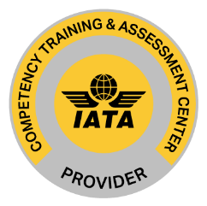
CBTA訓練及評估課程之前置規劃調查表-7.3

受訓人員所屬公司：
公司地址：
公司電話/分機：
指派受訓單位(窗口)：
受訓人員(或人數)：
受訓日期：
受訓地點：台北市南京東路二段100號3樓 (知性國際事業有限公司)
受訓人員工作性質：(請填寫)

受訓人員與危險貨物相關之工作項目
- Understanding the basics of dangerous goods
- Dangerous goods applicability
- Understanding the general limitations
- Identifying roles and responsibilities
- Understanding the importance of classification & packaging
- Understanding hazard communication
- Familiarizing with basic emergency response
- Processing/accepting cargo
- Review documentation
- Review package
- Complete acceptance procedures
- Collecting safety data
- Report dangerous goods accidents
- Report dangerous goods incidents
- Report undeclared/mis-declared dangerous goods
- Report dangerous goods occurrences
上述清單未納入或須增加之訓練事項：(請填寫)

